**Assignment # 03 (Part B of Assignment # 01)**

**Answer the following SQL Basic Questions of appended table:**

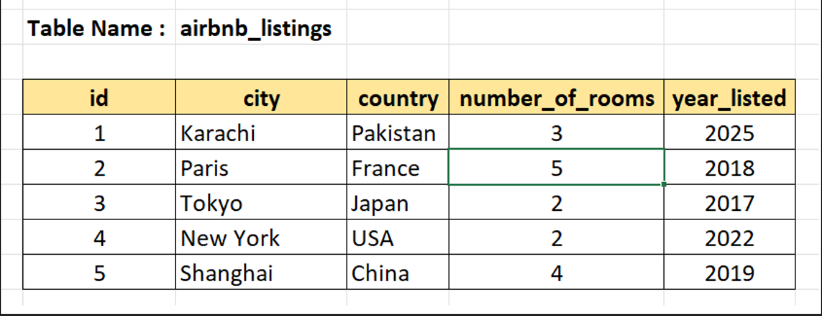

In this assignment, you will make practice of :

1. Querying Table
2. Filtering Data
3. Aggregating Data

**Instructions :**

* Use SQL , write the query against each question and execute /run.
* Take the screenshot with answer and paste against each question (with your Name in comment. I want your Name in each Screen shot to avoid cheating)

**Querying Table :**

1. Get all the columns from a table

**Ans** : 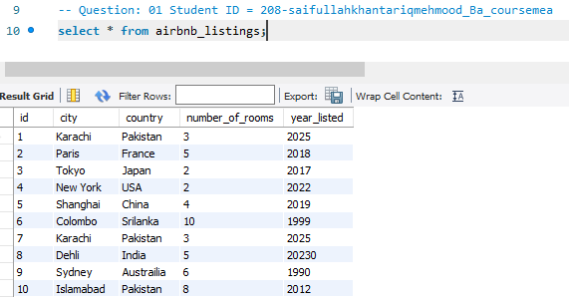

1. Get the city column from the table

**Ans :** 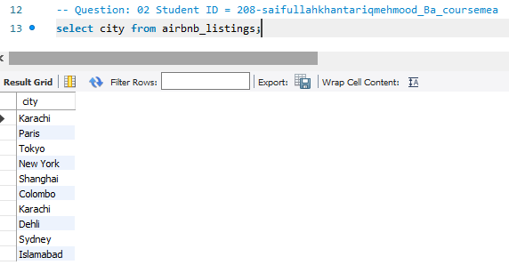

1. Get the city and year_listed columns from the table.

**Ans** : 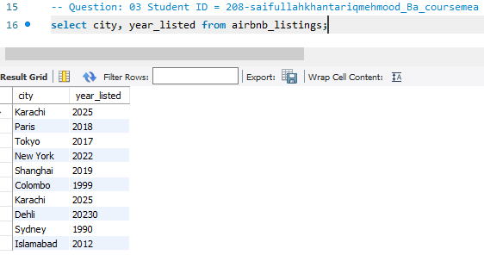

1. Get the listing id, city, ordered by the number_of_rooms in ascending order.

**Ans :** 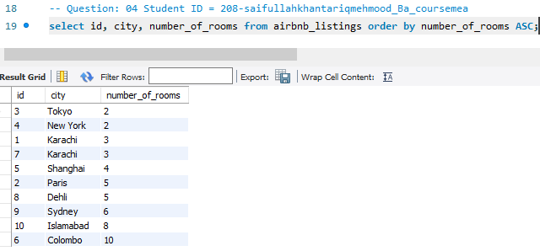

1. Get the listing id, city, numer of rooms , ordered by the number_of_rooms in descending order.

**Ans :** 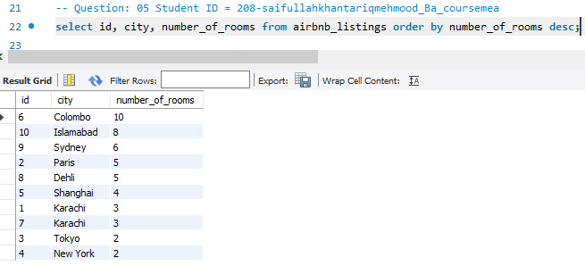

1. Get the first 5 rows from the airbnb_listings table.

**Ans :** 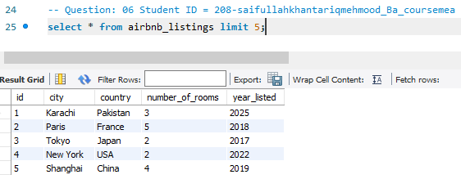

1. Get a unique list of cities where there are listings

**Ans :** 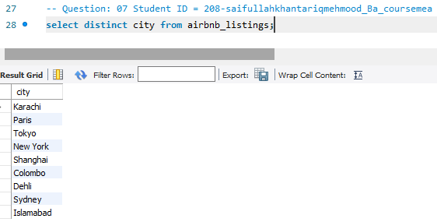

**Filtering Data :**

**Filtering on numeric columns**

1. Get all the listings where number_of_rooms is more or equal to 3.

**Ans :** 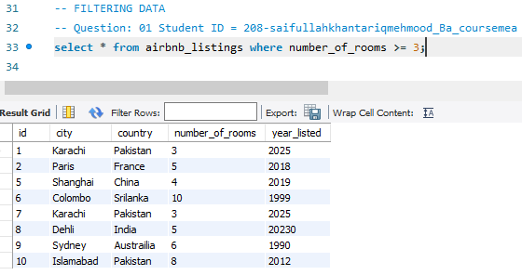

1. Get all the listings where number_of_rooms is more than 3.

**Ans :** 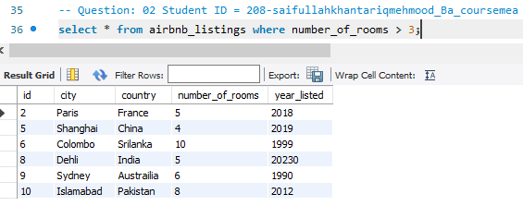

1. Get all the listings where number_of_rooms is exactly equal to 3.

**Ans :** 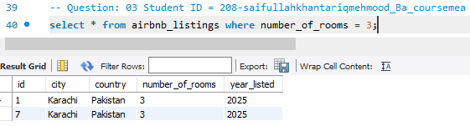

1. Get all the listings where number_of_rooms is lower or equal to 3.

**Ans :** 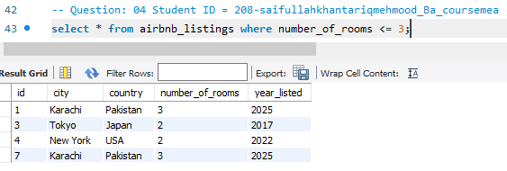

1. Get all the listings where number_of_rooms is lower than 3.

**Ans :** 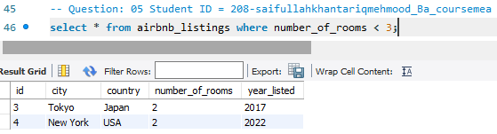

1. Get all the listings with 3 to 6 rooms

**Ans :** 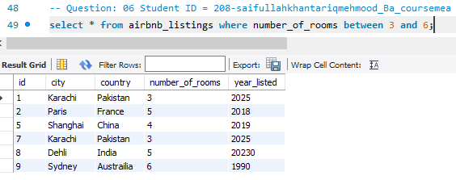

**Filtering on text columns**

1. Get all the listings that are based in 'Paris'.

**Ans :** 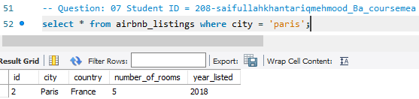

1. Get the listings based in the an 'USA' ' and in ‘France'.

**Ans:** 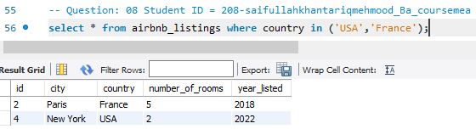

1. Get all the listings where the city starts with 'j' and where the city does not end in ‘t'.

**Ans :** 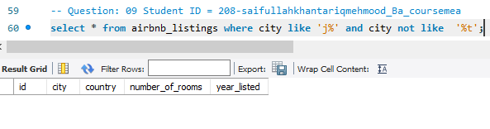

**Filtering on multiple columns.**

1. Get all the listings in 'Paris' where number_of_rooms is bigger than 3

**Ans:** 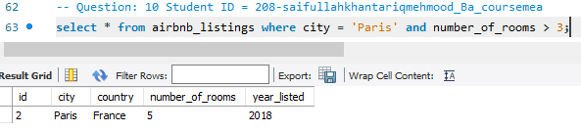

1. Get all the listings in 'Paris' OR the ones that were listed after 2012.

**Ans:** 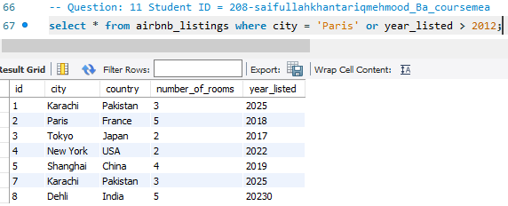

**Filtering on missing data.**

1. Return the listings where number_of_rooms is missing.

**Ans:** 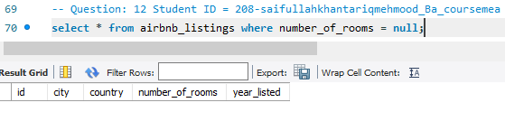

1. Return the listings where number_of_rooms is not missing

**Ans:** 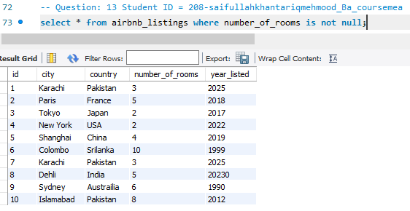

**Aggregating Data**

**Simple aggregations**

1. Get the total number of rooms available across all listings.

**Ans :** 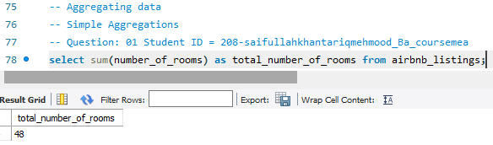

1. Get the average number of rooms per listing across all listings.

**Ans :** 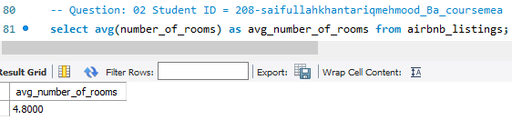

1. Get the listing with the highest number of rooms across all listings.

**Ans:** 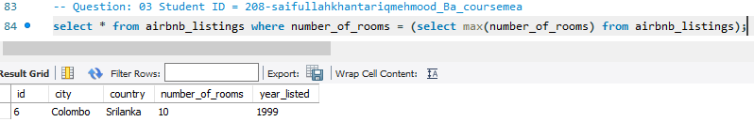

1. Get the listing with the lowest number of rooms across all listings

**Ans:** 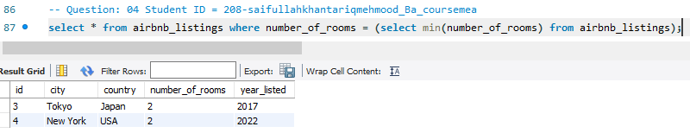

**Grouping, filtering, and sorting**

1. Get the total number of rooms for each country.

**Ans:** 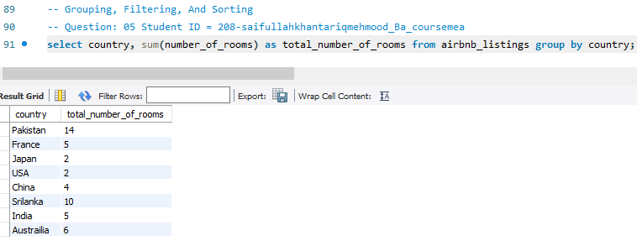

1. Get the average number of rooms for each country.

**Ans:** 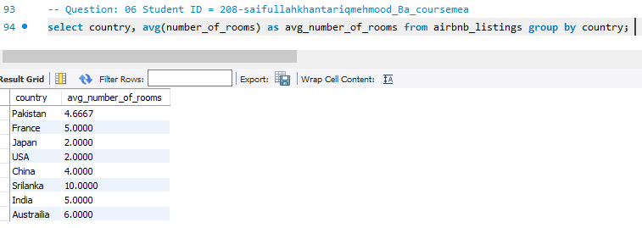

1. Get the listing with the maximum number of rooms per country.

**Ans:** 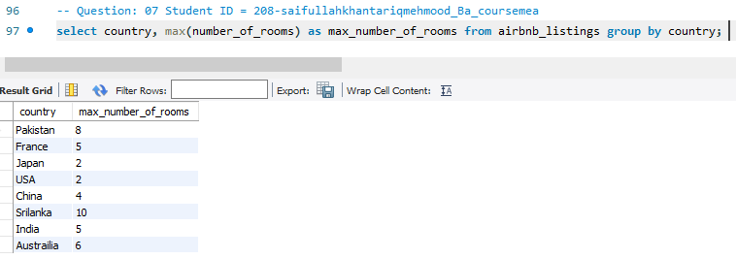

1. Get the listing with the lowest amount of rooms per country.

**Ans:** 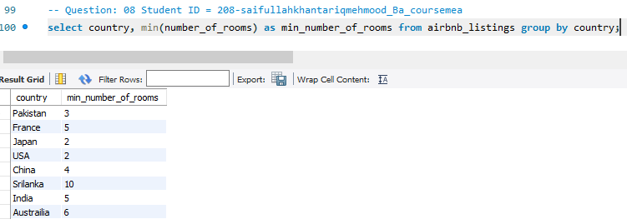

1. For each country, get the average number of rooms per listing, sorted by ascending order.

**Ans:** 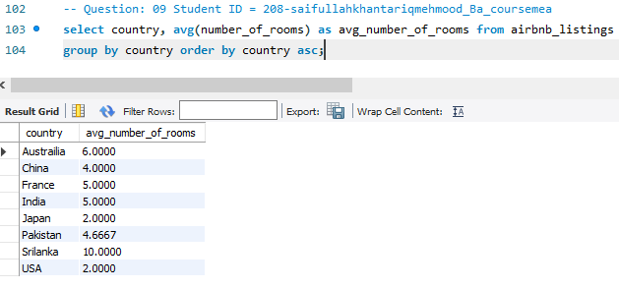

1. For Japan and the USA, get the average number of rooms per listing in each country.

**Ans:** 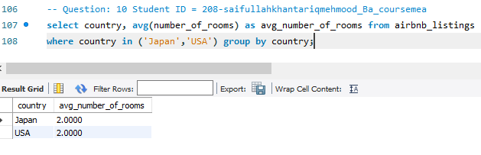

1. Get the number of cities per country, where there are listings.

**Ans:** 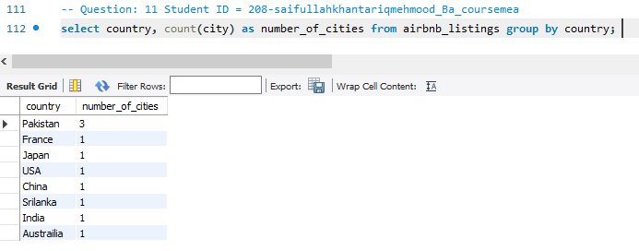

1. Get all the years where there were more than 100 ids per year

**Ans:** 